**[SMART WASTE MANAGEMENT SYSTEM WITH CONNECTED TRASHCANS (IOT)](https://www.researchgate.net/publication/351942006_Smart_Waste_Management_System_for_Smart_City_based_on_Internet_of_Things_IoT?enrichId=rgreq-67081ab379e9a7edf847e13d2711df31-XXX&enrichSource=Y292ZXJQYWdlOzM1MTk0MjAwNjtBUzoxMDI4NDM4NjU1NzcwNjMzQDE2MjIyMTAyOTE0Mjg%3D&el=1_x_3&_esc=publicationCoverPdf)**

**ABSTRACT**

Garbage collection is a time-consuming and inefficient procedure. Trucks empty bins whether they are full or nearly empty due to the consistent method of predefined routes and days. Many of those pit stops are a waste of gasoline, time, and effort, all of which add up to a large amount of money.

  Failure to separate recyclables from rubbish has a negative impact on the bottom line and reduces the lifespan of landfills. Recycling companies can't use rubbish that hasn't been separated. While some waste can be sorted at the point of collection, the procedure is inefficient and costly, a situation made worse by China's 2018 ban on the import and processing of foreign recyclables.

  The waste management industry's inefficiencies, costs, and environmental challenges are exacerbated by collection and segregation alone. However, the introduction and rising acceptance of IoT and [data analysis](https://www.analyticssteps.com/blogs/top-6-data-analysis-techniques) have resulted in data-driven solutions that were previously unaffordable.

**IoT based Waste Management**

Because of operational inefficiencies in trash collection procedures, the expanding usage of IoT, smart devices and sensors, and machine-to-machine communication has the potential to save money. And the key to it is the city's waste collection system, which is both complex and time- and resource-intensive. Let's take a look at how the IoT can help in this process.

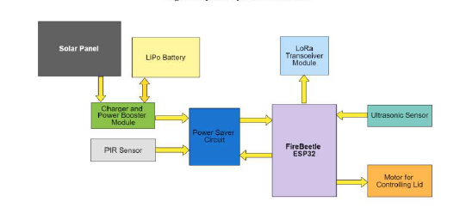

**BLOCK DIAGRAM**

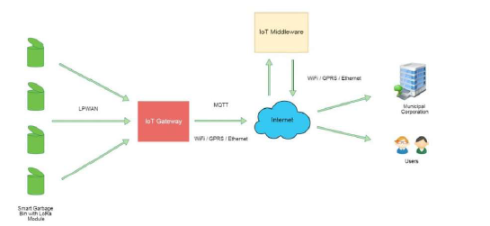

**A small sensor can go a long way:**

Everything today appears to be available in a "smart" version, from phones to homes to toasters. It's only a matter of time before garbage cans follow suit.

Ultrasonic and proximity-based sensors can alert collection trucks to full bins, assess segregation levels, and determine whether a driver should stop or continue. Weight sensors can also be used to track fill levels in larger bins.

This data can be used by fleet operations to track their cars and reroute them in real-time. When this data is combined with a scheduling engine, teams may design highly optimal collection plans and forecast what to expect weeks ahead of time.

Waste compactor-equipped bins can improve efficiency even more by holding more garbage in the same space and allowing collection vehicles to make fewer stops while picking up the same quantity of garbage.

When this material arrives at sorting facilities, technology can help there as well. At speeds faster than humans, cameras equipped with artificial intelligence (AI) and [computer vision](https://www.analyticssteps.com/blogs/what-computer-vision-and-how-does-it-work) algorithms can recognize streams that need to be separated.

  These advancements can also improve segregation quality and raise the value of recyclables by 200 to 300 percent. Finally, this technology aids in increasing revenue while lowering staffing costs.

Versions of these AI systems that may be deployed inside garbage bins and vehicles to assess segregation levels throughout the collection process are now being tested by the industry. This information can help operators figure out how to collect waste and where it should go. It can also provide information about waste generation in different areas of a city or neighborhood.

  *Sensors facilitating the Waste management process*

**1. Smart Dumpsters**

Smart dumpsters allow for more efficient waste collection. Simply put, these cutting-edge technologies enable trash management businesses to weigh dumpsters and report their capacity. Garbage collectors can use this information to solve urgent waste disposal needs. Drivers can also learn the quickest, most efficient routes with the help of IoT solutions.

Watch this video on *“ Smart Waste Management System”*

Smart dumpsters, in essence, collect data such as location, temperature, and fill levels and then transmit it to garbage management firms. This method is not only systematic, but it also ensures that pickups operate smoothly. The best part is that it helps you avoid missing or delaying your flight.

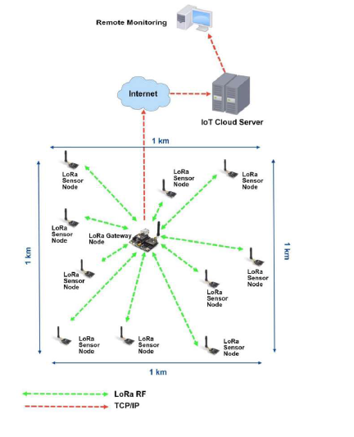

**2. Optimization of the Route**

The loads on disposal units might change according to the day, week, and season. A sensor can be attached to a dumpster to measure its fill level, which can be useful for municipalities or garbage management firms. These "smart" dumpsters may then provide waste collectors with real-time fill-level information.

Using this information, the IoT enterprise solution can determine the best paths for garbage collectors to take in order to prioritize regions in need of cleanup while avoiding disposal units that still have space. This results in a more efficient pickup operation that doesn't take into account empty garbage containers, saving both gasoline and manpower.

**3. No Missed Garbage Pickups**

The information obtained from the "smart" dumpsters also aids in the reduction of missed pickups. If the sensors detect that the garbage is full, the authorities will be notified automatically. The IoT waste management system will then be able to schedule this location for the next pickup. This streamlines the waste management process and eliminates garbage bin overflow.

**4. Analyzing Data in a More Streamlined Way**

It's never been easier to optimize data using IoT management systems. When smart devices connect, for example, they can reveal the speed at which bins fill up, the frequency with which bins are filled up, and the location of the nearest route.

This knowledge is priceless, as it makes it easier for workers and businesses to carry out practical tasks. Furthermore, these sophisticated tools aid in the detection and correction of soft underbellies. Disposal procedures are a major flaw, but with the use of IoT technology, these problems can be mitigated.

**5. Recycling in an Effective Way**

The increased number of consumer electronic devices ending up in landfills is a growing source of concern. This is due to the fact that they frequently include both hazardous compounds and valuable components.

For example, an aging smartphone's battery may leak lithium into the groundwater. This gadget, on the other hand, makes it easier to reclaim rare materials like gold than it is to mine them in the first place. Businesses can employ digital twins of sanitation systems to recycle e-waste for precious and finite resources thanks to the Internet of Things.

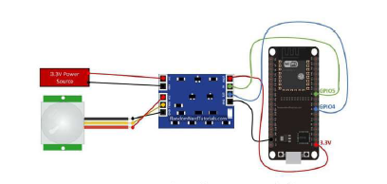

**SMART GARBAGE BIN STATUS SCREEN**

**CONCLUSION**

  Everyday urban operations are being managed by a growing collection of interconnected IoT devices, which are enhancing both citizen experiences and carbon footprint.

However, in order for IoT to make further inroads into waste management efficiency, we need more support from both the public and private sectors, including more regulation and incentives, as well as more innovation and engagement with various state agencies to use IoT applications to build a better and more sustainable future.